Photonics chips for machine learning

## Abstract

Over the years, machine learning has been playing an increasingly important role in various industries. Although the amount of computing power at people's fingertips started growing in leaps and bounds at the turn of the millennium, the computing demands of deep learning have been rising even faster and we can’t rely on Moore’s Law alone to continue improving electronics. This dynamic has spurred engineers to develop hardware accelerators specifically targeted to deep learning. Then, the more powerful and faster chip-----photonics chip was born.

## What is the significance of the research?

With electronic integrated circuits arriving at the end of their integration capacity, PICs have the potential to be the preferred technology for data communications (inter- and intra-datacenter communications), [LiDAR](https://www.synopsys.com/glossary/what-is-lidar.html) solutions for autonomous driving, sensing for aerospace and aeronautics, and untold future applications in a new technological era.

As global data consumption rises and demand for faster networks continues to grow, the world needs to find more sustainable solutions to the energy crisis and climate change. At the same time, ever more innovative applications for sensor technology, such as [Lidar](https://en.wikipedia.org/wiki/Lidar) in [autonomous driving vehicles](https://en.wikipedia.org/wiki/Self-driving_car), appear on the market.[[8]](https://en.wikipedia.org/wiki/Photonic_integrated_circuit#cite_note-8) There is a need to keep pace with technological challenges.

The expansion of [5G](https://en.wikipedia.org/wiki/5G) data networks and data centers, safer autonomous driving vehicles, and more efficient food production cannot be sustainably met by electronic microchip technology alone. However, combining electrical devices with integrated photonics provides a more energy efficient way to increase the speed and capacity of data networks, reduce costs and meet an increasingly diverse range of needs across various industries.

## What are applications of the topic?

The primary application for photonic integrated circuits is in the area of [fiber-optic communication](https://en.wikipedia.org/wiki/Fiber-optic_communication) though applications in other fields such as [biomedical](https://en.wikipedia.org/wiki/Biomedical)[[6]](https://en.wikipedia.org/wiki/Photonic_integrated_circuit#cite_note-6) and [photonic computing](https://en.wikipedia.org/wiki/Photonic_computing) are also possible.

The [arrayed waveguide grating](https://en.wikipedia.org/wiki/Arrayed_waveguide_grating) (AWG) which are commonly used as optical (de)multiplexers in [wavelength division multiplexed](https://en.wikipedia.org/wiki/Wavelength_division_multiplexing) (WDM) [fiber-optic communication](https://en.wikipedia.org/wiki/Fiber-optic_communication) systems are an example of a photonic integrated circuit which has replaced previous multiplexing schemes which utilized multiple discrete filter elements. Since separating optical modes is a need for [quantum computing](https://en.wikipedia.org/wiki/Quantum_computer), this technology may be helpful to miniaturize quantum computers (see [linear optical quantum computing](https://en.wikipedia.org/wiki/Linear_optical_quantum_computing)).

Another example of a photonic integrated chip in wide use today in [fiber-optic communication](https://en.wikipedia.org/wiki/Fiber-optic_communication) systems is the externally modulated laser (EML) which combines a [distributed feed back laser diode](https://en.wikipedia.org/wiki/Distributed_feedback_laser) with an [electro-absorption modulator](https://en.wikipedia.org/wiki/Electro-absorption_modulator)[[7]](https://en.wikipedia.org/wiki/Photonic_integrated_circuit#cite_note-7) on a single [InP](https://en.wikipedia.org/wiki/Indium_Phosphide) based chip.

One of the key application fields for PICs is data communications, followed by sensing (for agriculture and autonomous driving, for example), and biomedical applications such as lab-on-a-chip devices, as well as applications in the defense and aerospace industries and the field of astronomy. Improvements and additional applications for PICs continue to emerge as designers take on additional technological challenges for which integrated photonics may be useful and for which feasibility studies can determine whether it holds the promise of a solution. Services for such studies are provided by PIC consortia, design houses, and even some universities around the world.

## How it works

PICs use a laser source to inject light that drives the components, similar to turning on a switch to inject electricity that drives electronic components. Using light instead of electricity, integrated photonic technology provides a solution to the limitations of electronics like integration and heat generation, taking devices to the next level, the so-called “more than Moore” concept to increase capacity and speed of data transmission. when light travels and scatters in nonhomogeneous media it resembles some form of mathematical linear operation. The Figure 1 shows how we see things through our eyes.

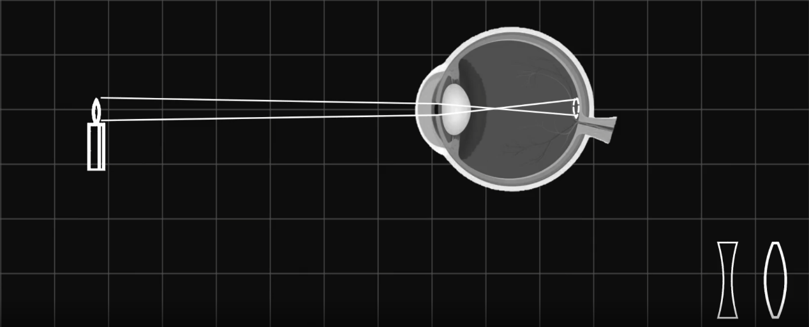

Figure 1

When light is limited from or scattered off and object, some of it reaches our eyes and eventually forms images on our retina. This process is a form of two-dimensional special Fourier Transform. Photonics MATMUL use light for the ubiquitous linear mathematic operation: vector matrix multiplication, or MATMUL for short. When light enters the system, it is encoded by an array of optical modulators to form an input optical vector. It then enters a field of programmable optical scattering media, which represents the matrix. After the input optical vector travels through the matrix, the output optical vector naturally represents the result of the MATMUL. The most attractive part here is the MATMUL itself is passive, meaning no energy is consumed in the process. Moreover, the MATMUL is completed within the time that light takes to pass through the matrix, which is only a fraction of a nanosecond. Finally, the energy efficiency and low latency properties are independent of input optical signal frequency, which means optical MATMUL could support large throughput. In summary, energy efficiency, low latency, and large groupers are the reasons we believe optical MATMUL is the key to continue scaling computing power beyond the MATMUL. For each optical MATMUL, the input vector values are first extracted from the on-chip SRAM, turned into analog values by the digital analog converter, and then apply to the corresponding optical modulators through micro bumps between the electronic chip and the photonics chip. The optical moderators then attenuate the incoming light accordingly, to form the input optical vector. The 64×64 optical matrix is encoded with a similar mechanism. The input optical vector then propagates through the optical matrix and generates the output optical vector. The output optical vector will hit an array of photodetectors, which turns optical intensity into electric current. The electric signals then travel back to the electronic chip through micro bumps, pass through transimpedance amplifiers and then analog-digital converters before returning to the digital domain. In total, thousands of micro bumps are used to facilitate data traffic between the electronic chip and photonics chips.

## research community

Matrix multiplication requires multiple operations, which the natural parallelism of optics can perform simultaneously, and integrated photonics are far more efficient than older bulk optical technologies. Optical transceivers consume less power than electronic ones, and if an optical neural network can be trained completely, the matrix can be left passive for further operation without consuming further power. Optical matrix multiplication can be performed at rates up to the photon detection rate, typically around 100 GHz—much faster than electronic clock rates of a few gigahertz.

The two most common components in AI integrated photonic chips are Mach-Zehnder interferometers (MZIs) and microring resonators (MRRs), both shown in Figure 2.

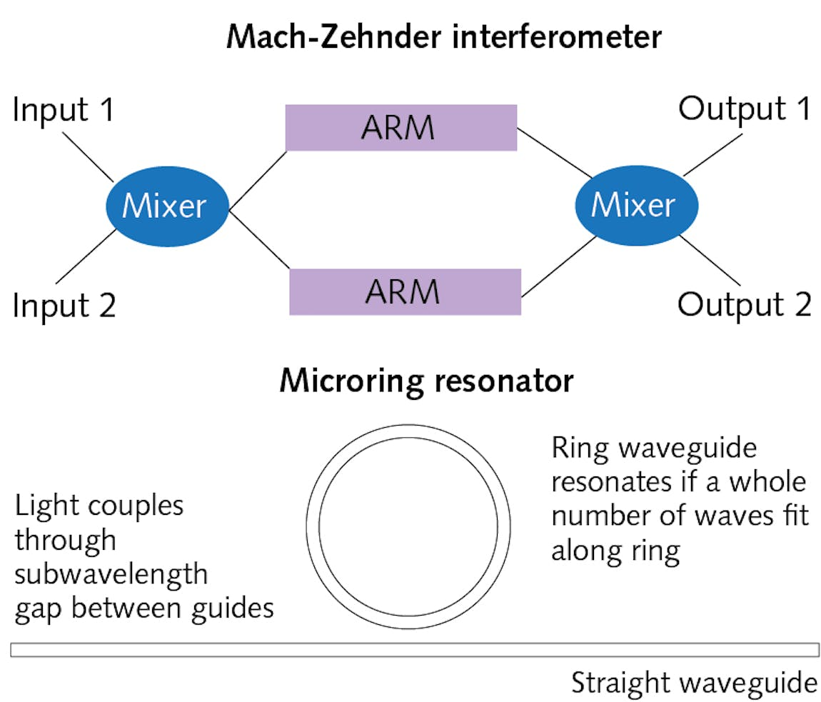

Figure 2

MZIs date back over a century. Two inputs at left mix, then are passed through two parallel arms where light is modulated to control its division between the two outputs at right. MRRs are more-recent inventions—tiny waveguide rings that can couple light through subwavelength gaps into other optical waveguides. Resonances occur along the lengths of the rings at wavelengths where a whole number of waves fits exactly around the length of the ring. Combining those two optical building blocks can make modulators, filters, multiplexers, switches, and computing elements.

Multiring resonators and MZIs can be combined with field-programmable gate arrays to perform optical vector matrix multiplication. Photonic deep-learning systems will use results of the operations to learn and recognize objects, and are expected to offer higher processing capacity and speed than purely electronic systems can now provide.

## industry

The fabrication techniques are similar to those used in electronic integrated circuits, in which [photolithography](https://en.wikipedia.org/wiki/Photolithography) is used to pattern wafers for etching and material deposition.

The platforms considered most versatile are Indium Phosphide (InP) and Silicon Photonics (SiPh):

[Indium Phosphide](https://en.wikipedia.org/wiki/Indium_phosphide) (InP) PICs have active laser generation, amplification, control, and detection. This makes them an ideal component for communication and sensing applications.

[Silicon Photonics](https://en.wikipedia.org/wiki/Silicon_photonics) (SiPh) PICs provide low losses for passive components like waveguides and can be used in minuscule photonic circuits. They are compatible with existing electronic fabrication.

Silicon Photonics actually refers to the technology rather than the material. It combines high density photonic integrated circuits (PICs) with complementary metal-oxide-semiconductor (CMOS) electronics fabrication. The most technologically mature and commercially used platform is Silicon on Insulator (SOI).

By combining and configuring different chip types (including existing electronic chips) in a hybrid or [heterogeneous integration](https://en.wikipedia.org/wiki/Multi-chip_module), it is possible to leverage the strengths of each. Taking this complementary approach to integration addresses the demand for increasingly sophisticated energy-efficient solutions.

# Open-Source research

<https://en.wikipedia.org/wiki/Photonic_integrated_circuit>

<https://www.synopsys.com/glossary/what-is-a-photonic-integrated-circuit.html>

<https://scitechdaily.com/photonic-chip-breakthrough-opens-a-path-toward-quantum-computing-in-real-world-conditions/>

<https://www.zmescience.com/science/news-science/ai-photonic-chip-07062022/>

<https://www.wired.com/story/chip-ai-works-using-light-not-electrons/>

<https://www.laserfocusworld.com/optics/article/14199572/how-photonic-integration-can-boost-artificial-intelligence>

<https://doi.org/10.48550/arXiv.2203.02285>

https://www.lightelligence.ai/index.php/product/index/2.html